**Final Exam in Graph Theory**

Exam period is two hours (120 minutes).

Answer the following questions. Total number of points is 140.

Write your name and student No. at the top of your answer sheet.

Justify and explain clearly every statement in your solutions.

Submit your answer sheet by email as PDF to [wimers@biu.ac.il](mailto:wimers@biu.ac.il) no later than 18:30. Later submissions will not be considered.

Good luck!

**Question 1** (70 Pts)

Prove that the faces of a planar graph $G$ can be colored by six colors such that adjacent faces (residing on the opposite side of their common edge) have different colors.

**Hints**:

* Use the fact that $\left|E\left(G^{*}\right)\right|≤3\left|V\left(G^{*}\right)\right|-6$ to show that $G^{*}$ (the dual of $G$) has a vertex of degree 5 at most.
* Then use induction on the number of vertices.

**Solution:**

* We consider $G^{*}$ the dual of $G$ and show it must have a vertex of degree 5 at most. Otherwise, the degree of all vertices is at least 6, implying

$6\left|V\left(G^{*}\right)\right|-12≥2\left|E\left(G^{*}\right)\right|=\sum_{v∈V\left(G^{*}\right)}{d\left(v\right)}≥6\left|V\left(G^{*}\right)\right|$,

which is impossible.

* Let $u∈V\left(G^{*}\right)$ be a vertex such that $d\left(u\right)≤5$. We show by induction on the number of vertices that $G^{*}$ is 6-colrable (vertex coloring).
* Assume by induction that $G^{*}\backslash u$ is 6-colrable.
* Since $d\left(u\right)≤5$ its neighbors consume at most 5 colors of the 6 used for $G^{*}\backslash u$. Assign to $u$ a missing color of the 6, yielding 6-coloring for $G^{*}$.
* Assigning the faces of $G$ with the corresponding colors of $V\left(G^{*}\right)$ completes the proof.

**Question 2** (70 Pts)

Let $G$ be a connected directed graph such that every cycle has equal number of arcs in directed clockwise and counterclockwise. Show that $G$ can be colored by $\left\{1,2,…\right\}$ such that for every arc $u→v$ the color of $u$ is $i$ and the color of $v$ is $i+1$.

**Hints**:

* Show that the difference $∆\left(u,v\right)=x-y$ of the out-going arcs $x$ and the in-going arcs $y$ along any path from $u$ to $v$ is uniquely determined (independent of the path).
* Notice that two different paths connecting $u$ to $v$ may intersect.
* Set the index of a vertex $u$, and then use $∆\left(u,v\right)$ to color all the rest vertices.

**Solution:**

* Let $p$ and $q$ be the number of clockwise and counter-clockwise arcs, respectively, along a cycle ($p=q$). Let $u,v∈V$ and consider a path from $u$ to $v$ which from connectivity must exists. Let $∆\left(u,v\right)$ be the difference between the number of out-going and in-going arcs along the path.
* The property $p=q$ holds also for the smaller cycles occurred by self-intersecting closed tours. $∆\left(u,v\right)$ must therefore be equal to all the paths from $u$ to $v$ (otherwise $p≠q$), hence $∆\left(u,v\right)$ is uniquely determined as shown in the illustration.

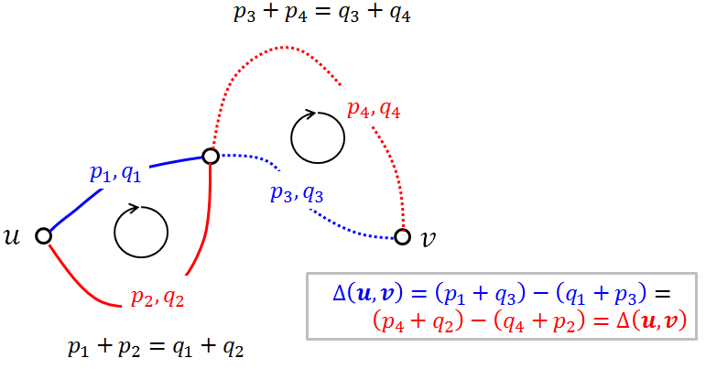

* Assigning a vertex the color $∆\left(u,v\right)$ yields coloring with the desired property.

**Comment**: To be more rigorous, the above proof should be replaced by induction on the number of intersections, but “hand waving” is fine.