**Question 1** (Connectivity 60 Pts).

Prove that a connected bipartite $k$–regular graph is $2$-connected.

Hints:

1. Prove by contradiction, consider the graph structure below.
2. Then consider the degree of $x$ in one of the subgraph and recall that any subgraph is still bipartite.

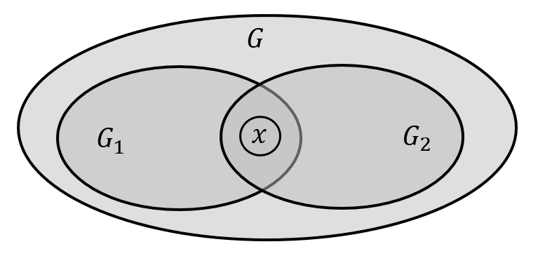

**Question 2** (Coloring 60 Pts).

Let $G$ be $\left(k+1\right)$ critical (every $G^{'}⊂G$ is $k$–colorable). Prove that $G$ is at least $k$–edge-connected (deletion of less than $k$ edges leaves $G$ connected).

Hint:

1. Prove by contradiction, separate $G$ into two pieces by edge deletion.
2. Color each piece and then match the colors of the two pieces such that $G$ is colored properly.

**Proof 1**: Assume in contrary that $G$ is not $2$-connected, hence it is $1$-connected.

Therefore, $G$ can be decomposed into two subgraphs $G_{1}$ and $G_{2}$ sharing a single vertex $x∈V\left(G\right)$, namely, $G=G_{1}∪G_{2}$, $V\left(G_{1}\right)∩V\left(G_{2}\right)=\left\{x\right\}$, $\left|V\left(G_{1}\right)\right|≥2$ and $\left|V\left(G_{2}\right)\right|≥2$.

Since $d_{G}\left(x\right)=k$ and $x$ is a disconnecting vertex, it must have neighbors in both $G_{1}$ and $G_{2}$, hence $1≤d_{G_{1}}\left(x\right)≤k-1$.

Since $G$ is $1$-connected, there is no edge connecting $V\left(G_{1}\right)-\left\{x\right\}$ to $V\left(G_{2}\right)-\left\{x\right\}$, hence $d_{G_{1}}\left(y\right)=k$ $∀y∈V\left(G_{1}\right)-\left\{x\right\}$.

Since $G$ is bipartite, let $V\left(G_{1}\right)=R∪S$, where $R=\left\{x,u_{1},u_{2}, …, u_{r}\right\}$ and $S=\left\{v_{1},v_{2}, …, v_{s}\right\}$ are in the two color classes of $G$, namely all $E\left(G_{1}\right)$ connect only vertices of $R$ to $S$. Hence $\left|E\left(G_{1}\right)\right|=\sum_{y∈R}{d_{G_{1}}\left(y\right)}=\sum_{y∈S}{d_{G_{1}}\left(y\right)}$.

$d_{G_{1}}\left(x\right)+kr=\sum_{y∈R}{d_{G_{1}}\left(y\right)}=\sum_{y∈S}{d_{G_{1}}\left(y\right)}=ks$.

It follows that the right hand side is divisible by $k$ whereas the left hand sides does not, hence a contradiction.

**Proof 2**: Assume in contrary that the deletion of $m<k$ edges $e_{1}$,…, $e_{m}$ separates $G$ into two components $G_{1}$ and $G_{2}$, and let $m$ be the smallest such number.

It follows that $∀e_{i}, 1≤i≤m$, the end vertices of $e_{i}$ belong to $G_{1}$ and $G_{2}$.

Since $G$ is $k+1$ critical, $G_{1}$ and $G_{2}$ are $k–$ colorable. So let $T_{1}$,…, $T_{k}$ and $S_{1}$,…, $S_{k}$ be the color classes of $G_{1}$ and $G_{2}$, respectively, i.e., $V\left(G_{1}\right)=\bigcup_{1≤i≤k}{T_{i}}$ and $V\left(G_{2}\right)=\bigcup_{1≤i≤k}{S_{i}}$.

We would like to match some $T_{i}$ with some $S_{i}$, such that for none of $e_{1}$,…, $e_{m}$ the same color appears on its two end vertices, thus ensuring $k-$ proper coloring in contradiction of its $k+1$ criticality.

Since $m<k$, there is an $S_{i}$ among $S_{1}$,…, $S_{k}$ not connected to $T_{1}$ by any edge of $e_{1}$,…, $e_{m}$.

We can certainly select this $S_{i}$ such that either $T_{1}$ or $S_{i}$ should be incident with some edge of $e_{1}$,…, $e_{m}$. So let us call this color class ${S'}_{1}$.

We are left with a matching problem of $k-1$ $T$ color classes with $k-1$ $S$ color classes and $m-1<k-1$. The above process can be repeated until all $e_{1}$,…, $e_{m}$ are consumed.