**Question 1** (Chromatic polynomial 40 Pts).

Consider the following $n$-vertex wheel graphs $G_{n}$ and ${G'}_{n}$, where $d\left(v_{n}\right)=n-1$ and ${G'}_{n}$ is obtained by removing an edge of $G_{n}$.

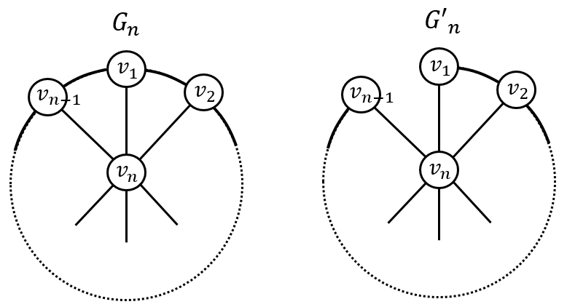

Prove the following:

1. (5Pts) $P_{{G'}_{n}}\left(k\right)=k\left(k-1\right){\left(k-2\right)}^{n-2}$
2. (10Pts) $P_{G_{n}}\left(k\right)=P_{{G'}_{n}}\left(k\right)-P_{G_{n-1}}\left(k\right)$
3. (15Pts) $P_{G_{n}}\left(k\right)=k\left(k-2\right)\left[{\left(k-2\right)}^{n-2}+{\left(-1\right)}^{n-1}\right]$ for $n≥4$ (use induction).

Let $P_{G}\left(k\right)=k^{4}-4k^{3}+5k^{2}-2k$.

1. (5Pts) How many vertices and edges $G$ has?
2. (5Pts) Is $G$ bipartite?

**Question 2** (Graph connectivity 40 Pts).

1. (25 Pts.) Let $G$ be connected such that its longest paths contain $n$ vertices. Let $P_{1}$ and $P_{2}$ be such longest paths in $G$ and $P_{1}≠P_{2}$. Prove that $P_{1}$ and $P_{2}$ must have a common vertex.
2. (15 Pts.) Let $G$ be connected and $e$ an edge of $G$. Suppose that every spanning tree of $G$ contains $e$. Show that $G\backslash e$ ( $e$ deleted) is disconnected.

**Question 3** (Cliques and independent sets 40 Pts).

Let $G\left(V,E\right)$ be such that $\left|V\right|=\left(\begin{matrix}k+l \\ k\end{matrix}\right)$. Show that either $K_{k+1}⊂G$ ( $k+1$ vertex clique) or $K_{l+1}⊂\overline{G}$ ( $l+1$ vertex independent set).

**Proof 3**: By induction on $k+l$.

For $k=1$ or $l=1$ the assertion is obvious.

Suppose that $k,l>1$. Let $v∈V$. There is

$d_{G}\left(v\right)+d_{\overline{G}}\left(v\right)=\left|V\right|-1=\left(\begin{matrix}k+l \\ k\end{matrix}\right)-1$.

There is

$$\left(\begin{matrix}k+l \\ k\end{matrix}\right)=\frac{\left(k+l\right)!}{k!l!}=\frac{\left(k+l-1\right)!}{k!l!}×\left(k+l\right)=\frac{\left(k+l-1\right)!}{\left(k-1\right)!l!}+\frac{\left(k+l-1\right)!}{k!\left(l-1\right)!}=$$

$\left(\begin{matrix}k+l-1 \\ k-1\end{matrix}\right)+\left(\begin{matrix}k+l-1 \\ k\end{matrix}\right)$.

Substitution yields

$$d_{G}\left(v\right)+d_{\overline{G}}\left(v\right)=\left(\begin{matrix}k+l-1 \\ k-1\end{matrix}\right)+\left(\begin{matrix}k+l-1 \\ k\end{matrix}\right)-1$$

Hence either

1. $d_{G}\left(v\right)≥\left(\begin{matrix}k+l-1 \\ k-1\end{matrix}\right)$ or (b) $d_{\overline{G}}\left(v\right)≥\left(\begin{matrix}k+l-1 \\ k\end{matrix}\right)$.

If case (a) $d_{G}\left(v\right)≥\left(\begin{matrix}k+l-1 \\ k-1\end{matrix}\right)$ holds, let $G_{1}⊂G$ be induced the neighbors of $v$. By induction hypothesis either $K_{k}⊂G_{1}$ or $K_{l+1}⊂\overline{G_{1}}$.

For $K_{l+1}⊂\overline{G_{1}}⊂\overline{G}$ we are done.

For $K_{k}⊂G_{1}$, the vertex set $V\left(K_{k}\right)∪\left\{v\right\}⊂V$ spans $K_{k+1}$ in $G$ hence $K_{k+1}⊂G$.

Same conclusions follow if case (b) $d_{\overline{G}}\left(v\right)≥\left(\begin{matrix}k+l-1 \\ k\end{matrix}\right)=\left(\begin{matrix}k+l-1 \\ l-1\end{matrix}\right)$ holds. $∎$