|  |  |  |
| --- | --- | --- |
| **BAR-ILAN UNIVERSITY (RA)**  Faculty of Engineering  Ramat-Gan 52900, Israel | **Tel: 03-5317722**  **engbi@mail.biu.ac.il** | **אוניברסיטת בר-אילן (ע"ר)**  הפקולטה להנדסה  רמת-גן 52900 |

**תורת הגרפים ושימושיה**

**תש"ף סמסטר ב' מועד ב'**

**83-652**

**מרצה:** פרופ' שמואל וימר

* הבחינה נערכת ב ZOOM. חובה לפתוח מצלמות וידאו. אי פתיחת מצלמה תגרור פסילת הבחינה.
* פתרון הבחינה חייב להיות בפורמט PDF. יש להעלותו בתוך חלון הזמן שארכו כמשך הבחינה + 15 דקות. אי העלאת קובץ הפתרון בזמן תחשב כאי הגשה.
* בבחינה שתי שאלות ומשקלן שווה. סה"כ הניקוד 120, ציון מקסימלי 100 נקודות.
* יש להקפיד על כתב יד ברור וקריא.
* מותר שימוש בכל חומר עזר.
* משך הבחינה: שעתיים.
* בראש דף הפתרון יש להעתיק ולחתום על ההצהרה הבאה. ללא הצהרה וחתימה הבחינה לא תיבדק .

אני מתחייב(ת) בזאת לשמור על טוהר הבחינה, לפתרה בכוחות עצמי בלבד ולא לעזור לשום גורם אחר שהוא. ידוע לי כי חשד כלשהו בטוהר הבחינה יאפשר לדרוש ממני להגן על פתרון הבחינה בעלפה.

שם התלמיד(ה):____________________חתימה: ________________________

**בהצלחה!**

1. (60 Pts) Prove that the faces of a planar graph $G$ can be colored by six colors such that adjacent faces (residing on the opposite side of their common edge) have different colors.

**Hints**:

* Use the fact that $\left|E\left(G^{*}\right)\right|≤3\left|V\left(G^{*}\right)\right|-6$ to show that $G^{*}$ (the dual of $G$) has a vertex of degree 5 at most.
* Then use induction.

**Solution:**

* We consider $G^{*}$ the dual of $G$ and show it must have a vertex of degree 5 at most. Otherwise, the degree of all vertices is at least 6, implying

$6\left|V\left(G^{*}\right)\right|-12≥2\left|E\left(G^{*}\right)\right|=\sum_{v∈V\left(G^{*}\right)}{d\left(v\right)}≥6\left|V\left(G^{*}\right)\right|$,

which is impossible.

* Let $u∈V\left(G^{*}\right)$ be a vertex such that $d\left(u\right)≤5$. We show by induction on the number of vertices that $G^{*}$ is 6-colrable (vertex coloring).
* Assume by induction that $G^{*}\backslash u$ is 6-colrable.
* Since $d\left(u\right)≤5$ its neighbors consume at most 5 colors of the 6 used for $G^{*}\backslash u$. Assign to $u$ a missing color of the 6, yielding 6-coloring for $G^{*}$.
* Assigning the faces of $G$ with the corresponding colors of $V\left(G^{*}\right)$ completes the proof.

1. (60 Pts) Prove that a directed connected graph $G$ can be colored by $\left\{1,2,…\right\}$ in such a way that for every arc $\left(u,v\right),$ $u→v$, the color of $u$ is $i$ and the color of $v$ is $i+1$, if and only if every cycle comprises equal number of arcs in each direction along the cycle.

**Directives**:

* (only if) Consider a cycle in $G$ with $p$ clockwise and $q$ counter-clockwise arcs and show that $p>q$ contradicts the coloring property.
* (if) Show that the difference $∆\left(u,v\right)=x-y$ of the out-going arcs $x$ and the in-going arcs $y$ along any path from $u$ to $v$ is uniquely determined. What does it mean for the required coloring?

**Solution:**

* Let a graph have the property such that it can be colored as above. Consider a cycle (undirected) in the graph comprising $p$ clockwise and $q$ counter-clockwise arcs. We have to show that $p=q$.
* Assume w.l.o.g that $p>q$ and traverse the cycle clockwise, starting at a clockwise arc $\left(u,v\right)$, with $u$’s color index $i$. Let $\left(w,u\right)$ be the closing arc of the cycle.
* If $\left(w,u\right)$ is a counter-clockwise arc, proper coloring implies that the color of $w$ should be $i+1$. However, the color index of $w$ is $i+p-\left(q-1\right)>i+1$. Hence $\left(w,u\right)$ cannot be colored properly.
* If $\left(w,u\right)$ is a clockwise arc, proper coloring implies that the color of $w$ should be $i-1$. However, the color index of $w$ is $i+\left(p-1\right)-q>i-1$. Hence $\left(w,u\right)$ cannot be colored properly.
* Similar arguments apply for $q>p$. Consequently $p=q$ and the assertion is proved.
* **Conversely**, let $p=q$ for every cycle of the graph. Pick a vertex $u$ and consider a path from $u$ to $v$. Denote by $∆\left(u,v\right)$ the difference between the number of out-going and in-going arcs along the path. See the illustration.

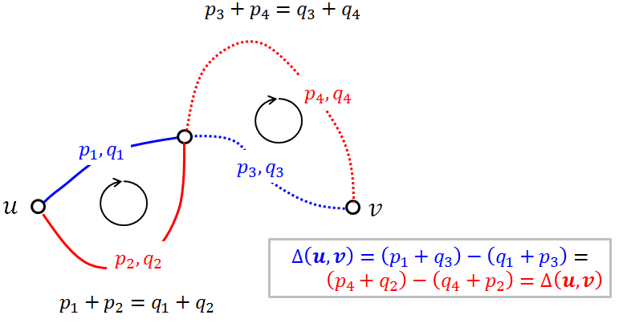

* The property $p=q$ must hold also for self-intersecting closed tours. This follows from the fact that a self-intersecting closed tour comprises smaller closed tours, connected at a vertex.
* Since the property $p=q$ holds for self-intersecting closed tours, $∆\left(u,v\right)$ must be equal to all the paths from $u$ to $v$ (otherwise $p≠q$), hence $∆\left(u,v\right)$ is uniquely determined.
* It is therefore possible to assign a vertex the color $∆\left(u,v\right)$, which obtains a coloring with the desired property.