Prof. S. Baranov
Dr. R. Finkelshtein

Introduction to Computer Engineering (83-252-02, 03)

Exam C

Instructions: 1. Duration for exam – 3 hours.
2. Materials for help – closed.

Problem 1 (30%). For given ASM:
- Construct Mealy FSM S₁ (direct transition table);

Problem 2 (20%). Decompose given FSM S₂ with the following partition on the set of states:
π = {A₁, A₂, A₃, A₄};
A₁ = {a₁,a₄}; A₂ = {a₃,a₆}; A₃ = {a₂ }; A₄ = {a₅, a₇ };
FSM S₃:

a1 a2 x1*x12*x11 y2 1
a1 a3 x1*x12*~x11*x8 y3y4 2
a1 a3 x1*x12*~x11*~x8*x5 y4y6 3
a1 a4 x1*x12*~x11*~x8*~x5*x6 y5 4
a1 a2 x1*x12*~x11*~x8*~x5*~x6 y2 5
a1 a7 x1*~x12*x11 y9y10 6
a1 a4 x1*~x12*~x11*x4*x2 y5 7
a1 a3 x1*~x12*~x11*x4*~x2 y3y4 8
a1 a3 x1*~x12*~x11*~x4*x2 y4y6 9
a1 a2 x1*~x12*~x11*~x4*~x2 y2 10
a1 a1 ~x1 -- 11
a2 a1 1 y1 12
a3 a2 x3 y2 13
a3 a3 ~x3 -- 14
a4 a5 x12 y4y7 15
a4 a3 ~x12 y4y6 16
a5 a2 x7 y2 17
a5 a5 ~x7 -- 18
a6 a3 x9*x10 y3y4 19
a6 a3 x9*~x10 y4y6 20
a6 a2 ~x9 y2 21
a7 a6 1 y8 22

Problem 3 (20%). For the given logic circuit, construct logic circuit with NOR-NAND gates.

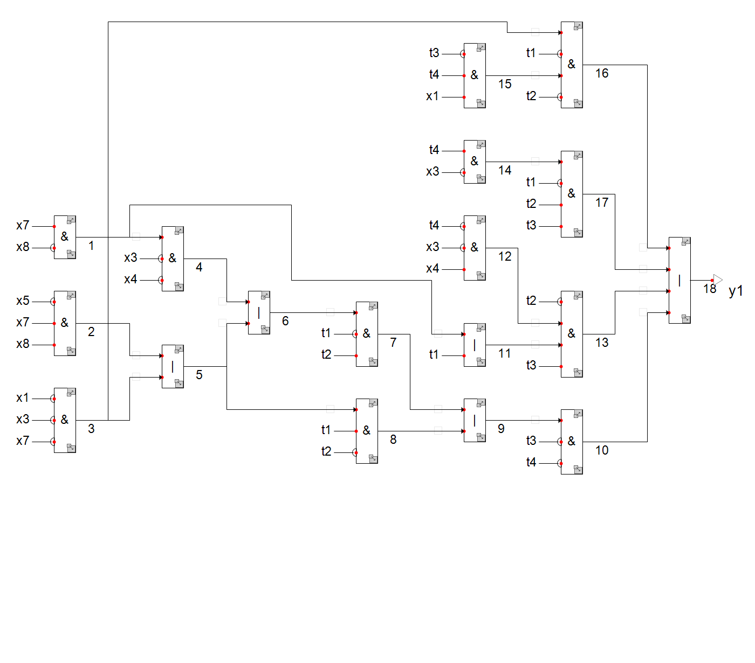

Problem 4 (30%). Construct two-level minimized logic circuit for the given abstract automaton, using optimal encoding for outputs and states. Use D flip-flops as memory elements. For minimization use Karnaugh maps at page 5.

 | a1 | a2
z1 | a2/w4 | a1/w2
z2 | -- | a2/w3
z3 | a1/- | a2/w4
z4 | a2/w1 | a1/w2
z5 | -- | a1/w3
z6 | a1/- | a2/w4
z7 | a2/w4 | a1/w2
z8 | -- | a1/w3
z9 | a1/- | a2/w1

Good luck!

Prof. Samary Baranov

