remote desktop on Windows Engineering Faculty Cluster using Bitvise

Dear User,
For a successful connection, make sure you have the following:
- Your EXACT username and password for the Faculty of Engineering network
- Bitvise SSH Client (Tunnelier) software is installed on your computer
- Google Authenticator software is installed on your mobile phone
- To get QR code, follow the guide on next link: 2 FA login remotely instruction

To connect remotely by Bitvise SSH client, please follow the next guide:

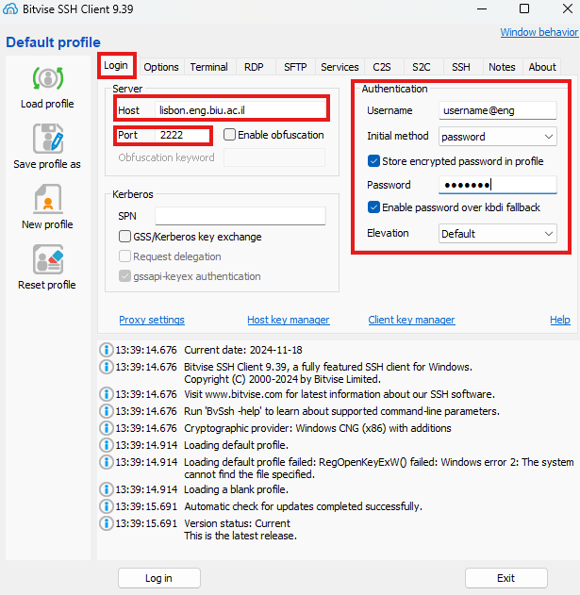

- Click on login tab
- On the host text box type – 2222
- On the username box, type your personal engineering username account@eng
- On the password text box, type your personal engineering network password
- Initial method, choose – Password
- Chek the store encrypted password in profile box
- Chek the Enable password over kbdi fallback box
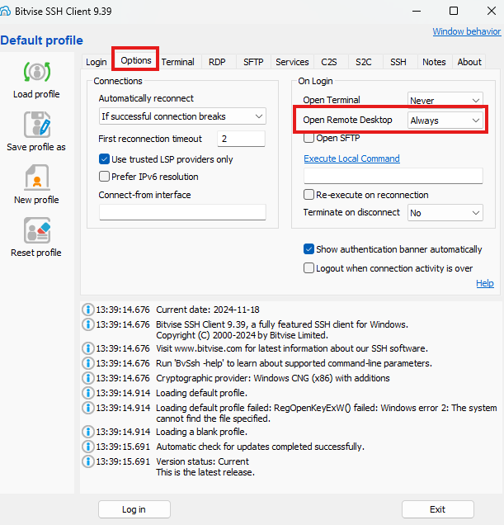

- On the option tab
- On the remote desktop choose Always

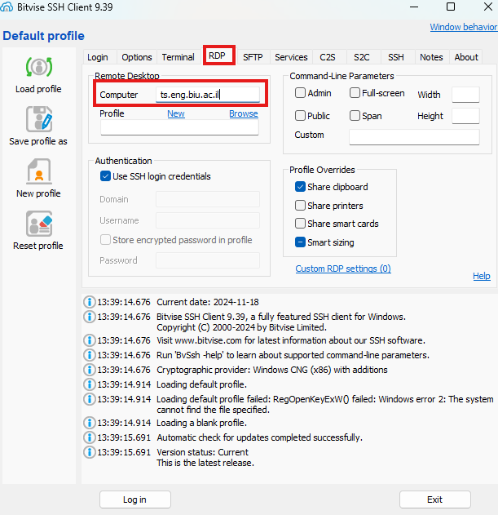
- On the RDP tab
- On "computer" text box, type the remote desktop IP address
- Click on Log in

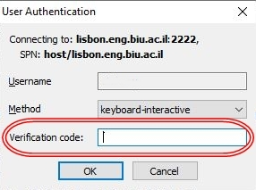

On the Verification code Text Box Type your Google Authenticator Code

